* Hầu hết các built-in annotation không apply được (chỉ có @Null và @NotNull)
* **Cách 1:** **sử dụng custom constraint** (dựa theo pattern column name)

Không an toàn

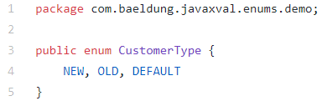

*Enum class*

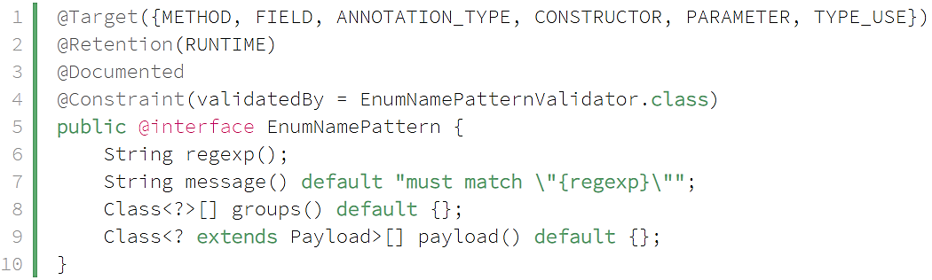

*Annotation interface*

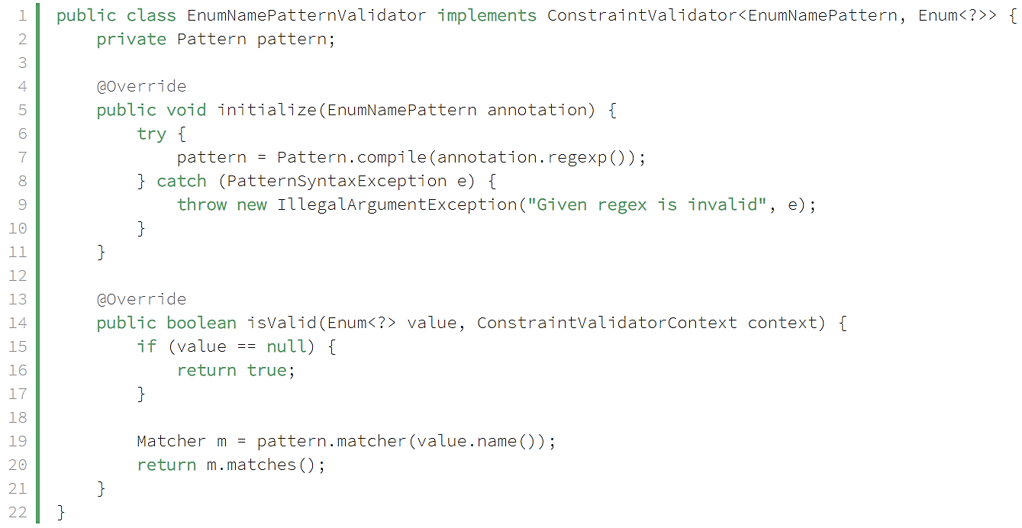

*Validator class*

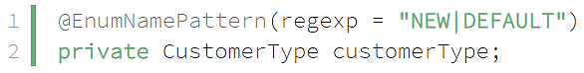

*Maching column name*

*Using*

* **Cách 2: Sử dụng @Pattern validator**

Sử dụng an toàn hơn cách 1



*Enum class*

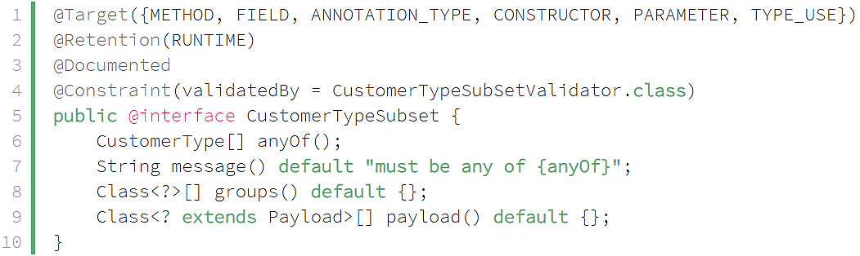

*Annotation interface*

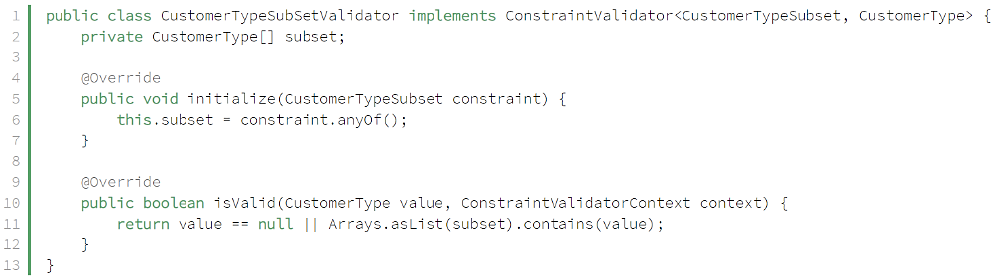

*Validator class*

**

*Using*

* + **Có thể tạo generic cho Enum Annotation**



*Enum class*

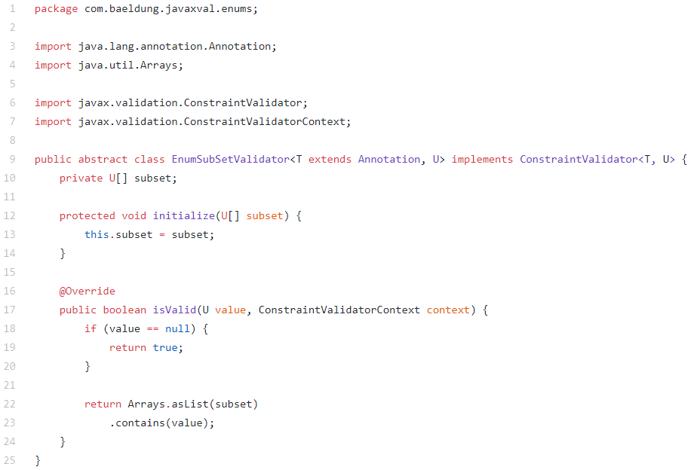

*Annotation interface*

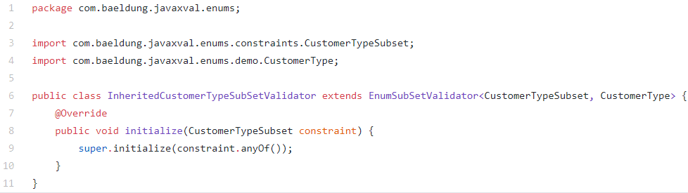

*Validator class*

*Using tương tự*

* **Cách 3: String matching Enum value**



*Enum class*

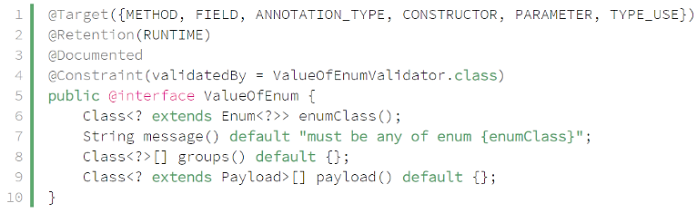

*Annotation interface*

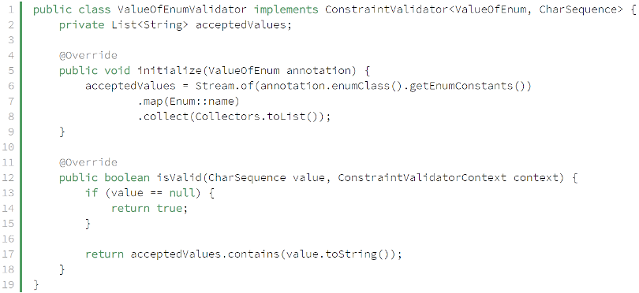

*Validator class*

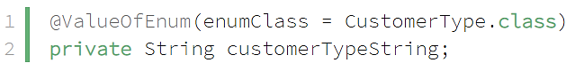

*Using*

* **Reference**

<https://www.baeldung.com/javax-validations-enums>